1.
Use the method of induction.

2.
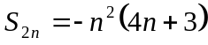 , 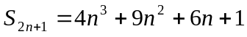 , 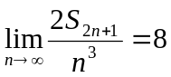.

3.
, 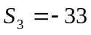 , 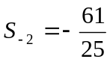

4.
(i) 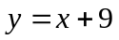 , 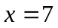
(ii) 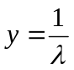 , , 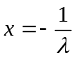

5.
(i) 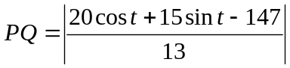
(iii) 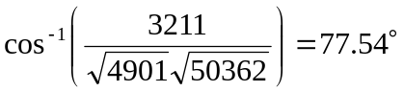

6.
(i) 3
(ii) 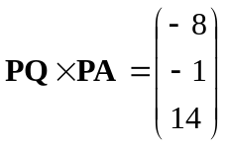
(iii) 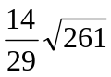
(iv) 